**Validate all Public cloud repdb reports we are receiving as per schedule :**

We have configured the script in MPC ATA domain jump host server 156.150.45.154 .The reports will generate every week. That reports are transferred to repdb billing team automatically .

Please check Output reports are generating or not.

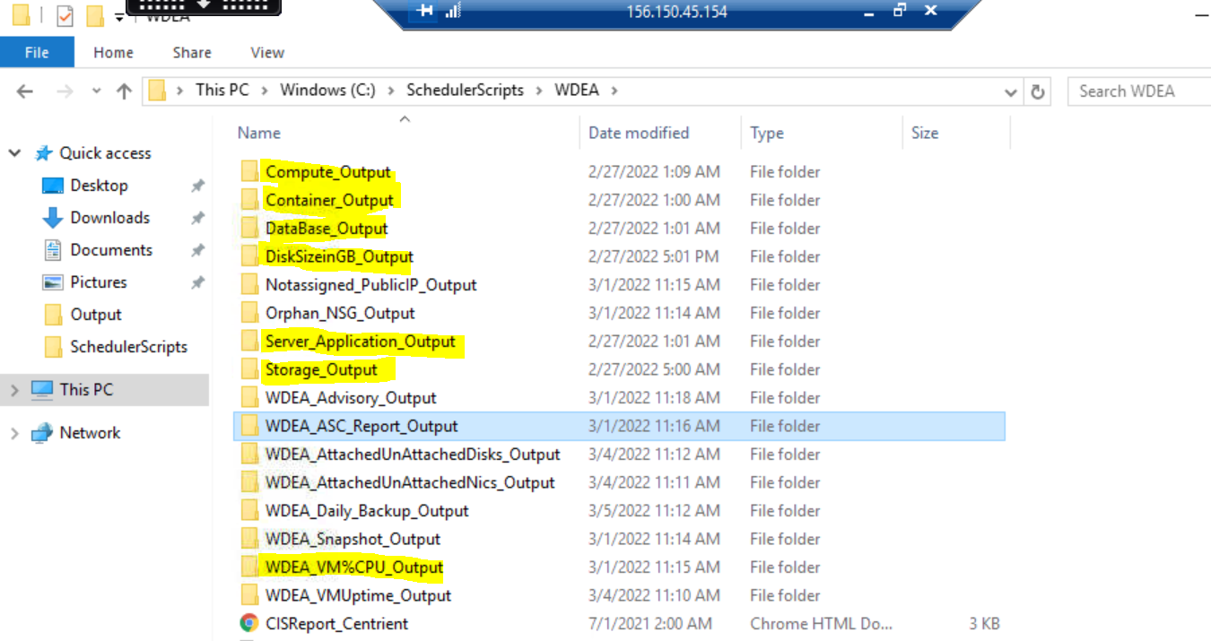

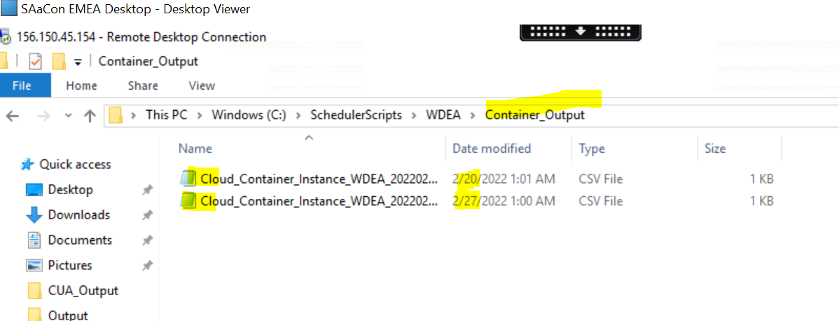

So if any issues in generating reports billing team will reach out to our team via mail. Please check mails and mention in remarks if any and work on the issue to resolve.